Project Design Phase-II

Data Flow Diagram & User Stories

|  |  |
| --- | --- |
| Date | 19October 2022 |
| Team ID | PNT2022TMID13705 |
| Project Name | Gas Leakage Monitoring and Alerting System |
| Maximum Marks | 4 Marks |

DATA FLOW DIAGRAM:

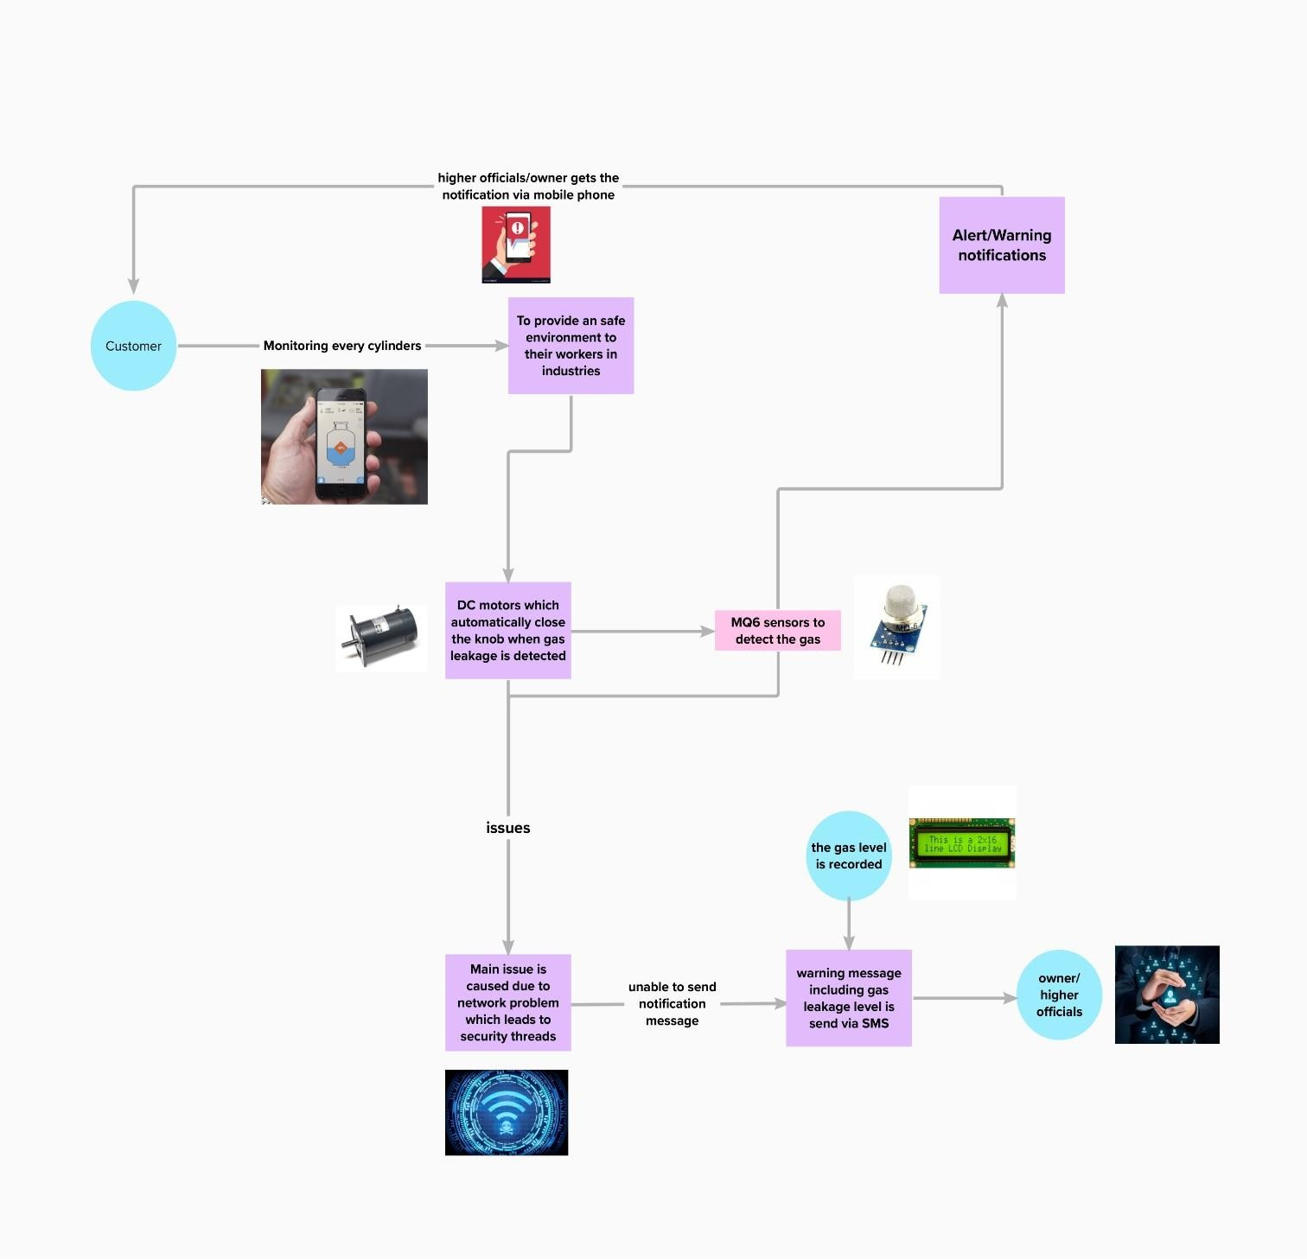FIGURE: DATA FLOW DIAGRAM-Gas Leakage Monitoring and Alerting System

User Stories

Use the below template to list all the user stories for the product.

|  |  |  |  |  |  |  |
| --- | --- | --- | --- | --- | --- | --- |
| **User Type** | **Functional**  **Requirement (Epic)** | **User**  **Story Number** | **User Story / Task** | **Acceptance criteria** | **Priority** | **Release** |
| Customer(family member/industry owner) | Registration | USN-1 | As a user ,I can register for the device in the owners mobile application by entering my email  and password | I can access my account / dashboard | High | Sprint-1 |
| Customer(higher authority) | confirmation | USN-2 | As a user I will receive confirmation message via email and once I received I can install the device in the  owners place | I can receive confirmation email & click confirm | High | Sprint-1 |
| Customer  (fire service 101) | Safety measure register | USN-3 | As a register I can register the  application in owner/family members mobile  phone | I can register & access the dashboard with Facebook Login | Low | Sprint-2 |
| Customer (mobile user) | Mobile application | USN-4 | As a user I can register by mobile application | I can register for gas detection device with owners mobile number and the alert message  will be send by SMS | Medium | Sprint-1 |
| Customer (credential) | Login | USN-5 | As a user I can log into the device by entering email & password in the owner’s mobile  application | Mail address and passwords are default | High | Sprint-1 |
| Customer (Web user) | Notification | USN-7 | As a user when there is a critical situation regarding gas explosion the alert notification will be received through  GSM module | Alert message is sent to owners mobile as an SMS | High | Sprint-1 |
| Customer care Executive | Network Connectivity | USN-8 | When there is a gas leakage is detected  in the surrounding | Sensor detect the leakage and notifies the owner via  message | High | Sprint-1 |

|  |  |  |  |  |  |  |
| --- | --- | --- | --- | --- | --- | --- |
| **User Type** | **Functional Requirement**  **(Epic)** | **User Story**  **Number** | **User Story / Task** | **Acceptance criteria** | **Priority** | **Release** |
| Administration | Accessing | USN-9 | When there is an  issue in accessing the device | Admin/Device operator’s advice should be undertaken | High | Sprint-1 |